**Group Project Report Stage 2** During the first stage of the group project, different possible solutions to the constraints imposed were found and the management plan was fixed for the second stage. The group project has now reached its objective: the EEBug prototype is now constructed, based on a circuit design performing the selected solutions to the constraints, and works as requested. This second project phase involved a deeper high level design, a low level design with its simulations and also a precise selection of components as a function of cost and performance. This report explains all of these aspects of the group project.Project summary

Management

The group’s members and their assigned role, specific tasks and main contribution are described in the table below. All the members attended the meetings and contributed to the success of the project.

|  |  |  |  |  |
| --- | --- | --- | --- | --- |
| Name | Position | Specific Task | Contributions | Issues |
| Lorenzo SCUTIGLIANI | Secretary | Logic | Passionate about circuit design, he also helped others with their tasks. |  |
| Alexandre  HADJ-CHAIB |  | Logic | Alexandre contributed to the logic circuit design and helped actively in testing the bug prototype. |  |
| Quentin  MCGAW | Leader | Sensor | Quentin helped elaborate the detecting sensor circuit and choosing the components. He kept a record of all meetings. |  |
| Leonardo IALONGO | Treasurer | Sensor | Leonardo designed the sensor’s amplification circuit and ensured the components ordered were appropriate. | Was sometimes late to meetings. |
| Hao  DING | Counter signatory | Timing | Designed a first version of the timing mechanism using digital. He checked orders submitted were correct and helped for the prototype testing. | Had to leave early on wednesdays because of other appointments. |
| Guang  YANG |  | Timing | Contributed to the design of the timing mechanism and helped in the testing. |  |

The main issue to be highlighted was the meetings. We in fact decided to have regular meetings on Wednesday afternoons. Although it accommodates most of the members, this did clash with some of the member’s personal timetables. To solve this issue we organized separate meetings with flexible times for specific tasks.

The deadlines established in the previous project stage to ensure the work for the project progress was carried out in time involved two minor issues. The first one happened when we decided to change the timing mechanism from a digital based solution to a completely analogue one. We then fell back in the established schedule by a week. The second issue was presented when ordering the prototype’s components. Because of an order mistake, the components were received later than expected. These issues were solved by a little extra work and by the flexibility of our planning. For the rest, the plan was followed properly and no changes in the management structure were made.

High Level Design

The final version of the circuit is composed of five different blocks: *time enabling system, sensor's amplification*, *spiral enabling system*, *motors' state assessment* and *motors' control system*. Each stage is discussed and analysed separately from a high level prospective in terms of inputs and outputs below.

# Time enabling system

This initial function dictates the state of the whole circuit (*ON* or *OFF*) and is time-controlled, since the circuit is required to begin its operation with a delay of 8s. The user’s input is processed to produce an output (E). The input-to-output relationship is summarised in the table below (Table 1):

|  |  |  |
| --- | --- | --- |
| **USER's INPUT** | **8s from INPUT** | **OUTPUT (E)** |
| LOW | LOW | LOW |
| LOW | HIGH | LOW |
| HIGH | LOW | LOW |
| HIGH | HIGH | HIGH |

Table 1: Time enabling system input-to-output relationships

A LOW user’s input implicates a constant LOW output. However, for a HIGH user’s input, the output stays at LOW for 8s and then switches to HIGH.

# Sensor's amplification

This function’s aim is to receive the sensor’s output and amplify it to allow successive stages to efficiently process it. In fact, the sensor is used to detect a black line over a white background and therefore produce two discrete states (ON-line or OFF-line). Its output needs to be compatible with the following digital stages, so the function produces two compatible discrete states (LOW and HIGH). The following table (Table 2) summarises the function input-to-output relations:

|  |  |
| --- | --- |
| **SENSOR's OUTPUT** | **OUTPUT (L)** |
| ON-line | HIGH |
| OFF-line | LOW |

Table 2: Sensor's amplification input-to-output relationship

This amplification stage is not the final one, so does not have to provide exact discrete states for the output, even if this one needs to tend to them. The output's swing is required at least to lie midway between these two states of reference.

# Spiral enabling system

This function determines whether or not the device reaches the end of the line and therefore if the spiral process has to be enabled. While following the line, the sensor regularly changes state from ON-line to OFF-line with an average period (TA). However, if during TA the change of state does not occur and the sensor's output is OFF-line, then the end of the line is reached. This stage is thus required to be time-controlled, processing the amplified sensor's output (L) to produce a time-varying output (S) lying between the two reference states. The following table (Table 3) summarises the function relationships:

|  |  |  |
| --- | --- | --- |
| **INPUT**  **(L)** | **TA from INPUT** | **OUTPUT (S)** |
| LOW | LOW | LOW |
| LOW | HIGH | HIGH |
| HIGH | LOW | LOW |
| HIGH | HIGH | LOW |

Table 3: Spiral enabling system input to output relationship

Again, since this is not the last amplification stage, the output is not required to be exactly close to the reference states. However, a threshold value is defined above which the time delay TA is reached and below which this one is not.

# Motors' state assessment

This stage processes and amplifies the previous functions’ outputs to determine the state of both motors (ON or OFF). This function accepts three inputs (E, L and S) and produces two amplified and strong outputs (ML and MR) each accepting the states LOW or HIGH. The function’s relationships are shown in (Table 4) below:

|  |  |  |  |  |
| --- | --- | --- | --- | --- |
| **INPUT**  **(E)** | **INPUT**  **(S)** | **INPUT**  **(L)** | **OUTPUT**  **(ML)** | **OUTPUT**  **(MR)** |
| LOW | LOW | LOW | LOW | LOW |
| LOW | LOW | HIGH | LOW | LOW |
| LOW | HIGH | LOW | LOW | LOW |
| LOW | HIGH | HIGH | LOW | LOW |
| HIGH | LOW | LOW | LOW | HIGH |
| HIGH | LOW | HIGH | HIGH | LOW |
| HIGH | HIGH | LOW | HIGH | HIGH |
| HIGH | HIGH | HIGH | HIGH | LOW |

Table 4: Motors' state assessment input-to-output relationship

If the circuit is not enabled (E, LOW), both motors are turned off (*MR LOW ; ML LOW)*. However, if the circuit is enabled (E, HIGH), then the state of both motors is exclusively determined by the   
states (L ; S). If the end of the line is not reached (*S, LOW*), then if the sensor is ON-line (*L, HIGH*), the device turns right (*MR LOW ; ML HIGH*). Otherwise, if the sensor is OFF-line (*L, LOW*), the device turns left (*MR HIGH ; ML LOW*). As a result, the device follows the right edge of the line.

Now if the end of the line is reached (*S, HIGH*), then if the sensor is ON-line (*L, HIGH*), the device still turns right (*MR LOW ; ML HIGH*). However, if the sensor is OFF-line (*L, LOW*), then both motors are turned on (*MR HIGH ; ML HIGH*). In the last case, by appropriately controlling the speed of each motor, a spiral is obtained.

# Motors' control system

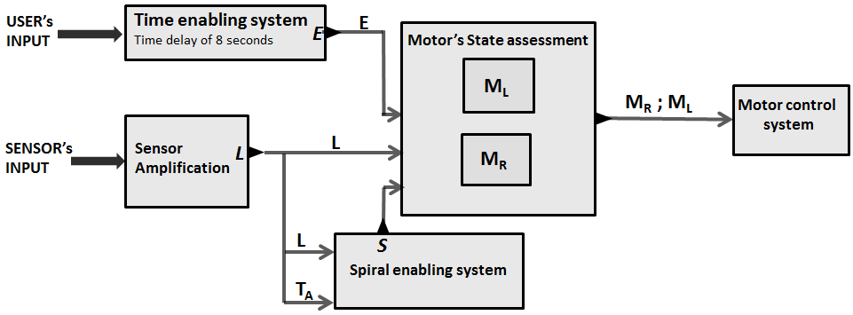 This last stage controls both motors in terms of speed based on the previously assessed states *MR* and *ML*. While the device follows the line, the motors are expected to constantly change state with a high frequency. But when the end of the line is reached, both motors stably turn on resulting in no appreciable switching frequency. By reducing the speed of both motors over a certain time TM which reset each time switching occurs, a decreasing speed is obtained in this last case. If appropriately controlled, this generates a spiral.  
  
  
  
 All of the functional blocks relationships are summarised in the following (figure 1).

*Figure 1: Relationships between each functional blocks*

Low Level Design

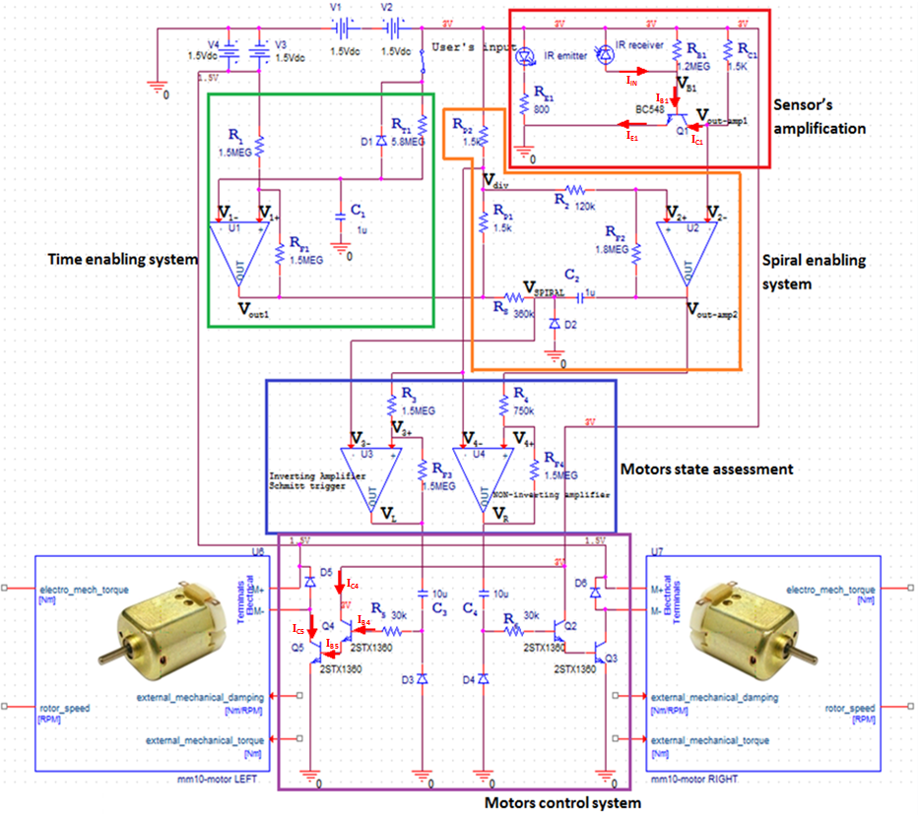 Now, each module previously described from a high level prospective is analysed in details and the circuits behind them as well as their connections are unveiled. The complete circuit with its different blocks is shown below (figure 2).

*Figure 2: Complete Circuit divided in functional blocks*

# Time enabling system

To achieve the previously described time enabling system, the operational amplifier U1 with positive feedback is used. In particular, an inverting Schmitt Trigger configuration with dynamic threshold is implemented with this last one. Therefore, assuming no current is drawn by the op-amp inputs and using KCL at its positive input V1+ gives:



Simplifying and rearranging in function of V1+ :

**(2)**

Since the positive and negative supply voltages of the op-amp are respectively 3V and 0V, VOUT1 is either 3V or 0V because of positive feedback and the dual threshold is therefore given by:

**(3) $V_{1+}=\frac{3}{2}±\frac{3}{2}\frac{R_{1}}{R_{1}+R_{F1}}$**

Consequently, by choosing R1=RF1, the threshold voltage is set at either 2.25V (VOUT1 = 3V) or 0.75V (VOUT1 = 0V). In particular, R1 and RF1 are chosen to be equal to 1.5MΩ. This reduces the power consumption of the device without compromising its performance.

To control the time switching of the op-amp, a simple RC configuration is implemented at the op-amp's negative input V1- . With this arrangement, if the user's input is 0V (OFF) and because of the diode D1, the capacitor C1 completely discharges: immediately V1-=0V, Vout1=3V and the threshold is set to 2.25V. But if the user's input switches to 3V, then C1 begins to charge and V1- , assuming no current is drawn, is given by:

**(4) $V_{1-}=3(1-e^{(\frac{-t}{R_{T1}C_{1}})})$**

Simplifying and rearranging as a function of RT1 gives:

**(5) $R_{T1}=\frac{t}{C_{1} ln(\frac{3}{3-V_{1-}})}$**

Therefore, since a delay of 8 seconds is required and the threshold voltage is 2.25V (V-), by choosing C1 = 1µF, the value of RT1 is determined to 5.8MΩ. To sum up, if the user's input is 0V, then VOUT1 immediately becomes 3V, and if it is 3V, then the VOUT1 switches from 3V to 0V after a delay of 8s.

# Sensor's amplification

To determine if the device is on the black line, an infrared emitter/receiver diode pair is used. From the manufacturer's datasheets, for currents smaller than 10mA, the following relationship between RE1 and IE1 for the infrared emitter holds:

**(6) $R_{E1}=\frac{1.6}{I_{E1}}$**

In order to reduce the power consumption, IE1 is set to 2mA, so RE1 is determined with equation (6) to around 800Ω.

Now, to a certain current flowing through the emitter corresponds an amount of emitted infrared radiations. Similarly, to a certain amount of received infrared radiations, a certain current is allowed to flow backwards in the receiver. In fact, black absorbs infrared radiations while white reflects them. Pointing both emitter and receiver towards the ground, two discrete current values at the receiver can be recorded, depending on the ground's colour (white or black). These values are recorded by pointing the sensors towards the line (IZ) and then towards the white background (IA):   
IA=1.88μA and IZ=0.90μA.

To amplify the receiver's current signal (IIN) a C-E amplifier with a single bipolar transistor is implemented. The following equations are describing its behaviour:

**(7) $I_{C1}=\frac{3-V_{out-amp1}}{R_{C1}}$**

**(8) $I_{B1}=\frac{I_{C1}}{β}=\frac{3-V_{B1}}{R_{B1}}+I_{IN}$**

Since the output's swing is required to lie midway between 3V and 0V, for VC1 = 1.5V:

**(9) $I_{IN}= \frac{I_{A}+I_{Z}}{2}$**

Combining (8) and (9) and rearranging as a function of RB1:

**(10) $R_{B1}= \frac{2(3-V_{B1})}{2\frac{I_{C1}}{β}-(I_{A}+I_{Z})}$**

To reduce the power consumption of the device, the collector current IC1 is set to 1mA. The value of RC1 is then determined using equation (7) with VOUT-AMP1=1.5V to approximately 1.5kΩ. Using the manufacturer's datasheet for the transistor, the beta value is 295 for this collector current. Moreover, assuming VB1 = 0.6V and using the previously measured values of IA and IZ, the value of RB1 is determined using equation (10) to around 1.2MΩ.

The small signal analysis gives the small signal output voltage swing by :

**(11) $v_{out}=∓\frac{3r_{o}R_{C1}β\left(3-V_{B1}\right)(I_{A}-I_{Z})}{2\left(R_{C1}+r_{o}\right)\left[3V_{T}-V_{T}βR_{C1}\left(I_{A}+I_{Z}\right)+3(3-V_{B1})\right]}$**

Assuming $r_{o}≫R_{C1}$, VT = 25mV and VB1 = 0.6V, $v_{out }$ is deduced from equation (11) to approximately 0.2V.

If the sensor is on the black line, then the amplified output voltage VC1 is thus expected to be around 1.7V. If the sensor is on the white, then VC1 is expected to be 1.3V.

# Spiral enabling system

To implement the spiral enabling function, the op-amp U2 is used as an inverting Schmitt trigger together with an RC circuit. The op-amp acts as a second amplification stage for the sensor's output, while the RC circuit controls the duration *t* the sensor stays off the line.

If the circuit is enabled, the potential divider between the time enabling system's output (0V) and the 3V supply must supply 1.5V to the resistance R2. Consequently, RP1 and RP2 need to be equal, small enough to supply an unvarying voltage, and not too small to avoid large power consumption. Consequently, a value of 1.5kΩ is chosen for them.

With this potential divider, the relation between R2, RF2 and the dual threshold voltage of U2 is the same as in (3). Since the output voltage swing with respect to 1.5V of the amplified sensor's output is 0.2V, the dual threshold voltage swing is set to $±0.1V$. Using equation (3) only considering the threshold voltage swing (*x*) with respect to 1.5V and rearranging as a function of RF2:

**(12) $R_{F2}=\frac{(1-\frac{2}{3}x)}{\frac{2}{3}x}R_{2}$**

For x = 0.1V, RF2 is determined with equation (12) to be 15 times R2. RF2 and R2 are hence chosen to respectively 1.8MΩ and 120kΩ resistors. Consequently, if the sensor is on the line, the op-amp output VOUT-AMP2 is expected to be 0V while if the sensor is off the line, VOUT-AMP2=3V.

The op-amp output is then connected to the capacitor C2 with the resistor RS in series, itself connected to the time enabling system's output VOUT1. Moreover, the diode to ground D2 is connected towards the function's output VSPIRAL, situated between Rs and C2. Now, if the circuit is enabled (VOUT1=0V), then when VOUT-AMP2=0V (on the line), no matter the charge across C2, VOUT-AMP2 stays at 0V. In fact, if C2 is charged and VOUT-AMP2=0V, then VSPIRAL is negative and current immediately flows through the diode D2 to discharge C2 bringing VSPIRAL to 0V. Now when VOUT-AMP2=3V (off the line), then VSPIRAL varies with time according to the following equation:

**(13) $V_{S}=3e^{(\frac{-t}{R_{S}C_{2}})}$**

Simplifying and rearranging in function of RS:

**(14) $R_{S}=\frac{t}{C_{2} ln(\frac{3}{V_{S}})}$**

Consequently, the longer the sensor stays off the line, the lower VSPIRAL is. Now, defining a threshold voltage VT = 0.75V below which the sensor stays more than TA = 0.5s off the line and setting C2=1µF, RS is determined using equation (14) to 360kΩ.

To sum up, if the sensor stays more than 0.5s off the line, VOUT-AMP2=3V and VSPIRAL<0.75V, implicating the beginning of the spiral phase. However, if the circuit is disabled, then VOUT1 switches to 3V. The potential divider provides 3V to U2 and the dual threshold increases to approximately 2.8V. Since U2’s negative input V2- ranges from 1.3V to 1.7V, VOUT-AMP2 stays at 3V. Consequently, VSPIRAL=3V, no matter the sensor’s state.

# Motors' state assessment

To assess the state of both motors (*ON* or *OFF*), the two op-amps U3 and U4 are respectively used as an inverting Schmitt trigger and as a NON-inverting Schmitt trigger. Now, the voltage VDIV of the previously discussed 1.5k/1.5k potential divider is connected to the negative input V4- of U4 and to the resistance R3 itself connected to the positive input V3+ of U3. The output VSPIRAL is connected to V3-. The resistance R4 in front of the positive input V4+ of U4 is connected to the second amplification stage output voltage VOUT-AMP2.

If the circuit is enabled, the relation between R3, RF3 and the dual threshold voltage of U3 is the same as in (3). However, the relation between these three quantities is different for U4. More specifically, assuming no current is drawn by the op-amp inputs and using KCL at V4+ gives:

**(15) $\frac{V_{div} -{ V}_{OUT-AMP2}}{R_{4}}+\frac{V_{div} -{ V}_{R}}{R_{F4}}=0$**

Replacing Vdiv=1.5V and rearranging in function of VOUT-AMP2:

**(16) ${ V}_{OUT-AMP2}=\frac{3}{2}+\frac{\left(V_{R }- \frac{3}{2}\right){ R}_{3}}{R_{F3}}$**

Since the supply voltages of U4 are 3V and 0V, VR is either 3V or 0V because of positive feedback and therefore the dual threshold is given by:

**(17) ${ V}_{OUT-AMP2}=\frac{3}{2}±\frac{3}{2 }\frac{R_{3}}{R_{F3}}$**

The inverting Schmitt Trigger has to amplify VSPIRAL. Since the spiral should start when VSPIRAL<0.75V, the lower dual voltage needs to be 0.75V. Therefore, the same resistance values used in the *time enabling system*'s U1 op-amp can be used. In other words, R3=RF3=1.5MΩ.

However, the purpose of the NON-inverting Schmitt Trigger is simply to maintain the signal coming from VOUT-AMP2 (*Spiral enabling function*) in phase with the amplified VSPIRAL. Actually, U3 and U4’s output controls the state of one of the motors. If the NON-inverting op-amp is omitted, the circuit would work but a motor would switch ON and OFF faster than the other. Consequently, the values of R4 and RF4 are not important. However, the dual threshold voltage is set to the same in both op-amps. Therefore, to obtain the same dual threshold voltage, equation (17) can be rearranged, giving:

**(18) $R_{F4}=\frac{3}{2}\frac{R_{4}}{({ V}_{OUT-AMP2} - \frac{3}{2})}$**

For VOUT-AMP2=2.25V, RF4 is determined with equation (18) to be twice R4. To maintain low power consumption, RF4 and R4are chosen to be respectively 1.5MΩ and 750kΩ.

Now, if the circuit is enabled and the sensor is on the line, then VOUT-AMP2=VSPIRAL=0V. Furthermore, the inverting amplifier output VL=3V while the NON-inverting output VR=0V. As a result, since the device needs to follow the right edge of the line, U3 assesses the state of the left motor (ML) while U4 is assesses the state of the right motor (MR).

In the other hand, if the sensor is off the line, then initially VOUT-AMP2=VSPIRAL=3V.   
Consequently, VL=0V while VR=3V as expected. However, if the sensor stays off the line for more than 0.5s, VSPIRAL<0.75V and VL switches to 3V.

Finally, in the case where the circuit is disabled, VOUT-AMP2=VSPIRAL=Vdiv=3V. And because of the positive feedback, VL and VR would switch to 0V: both motors are then turned off.

# Motors' control system

To implement the motors' control system, a symmetrical circuit for each motor is designed with two power bipolar transistors and an RC circuit. The motor is connected between the 1.5V power supply and the collector of the transistor Q5 (or Q3 symmetrically) whose emitter is grounded. Only 1.5V supplies the motor to limit its speed, giving enough time to the sensor and the circuit to detect the change of state and process it. Moreover, to protect the transistor a diode is connected in parallel between the inputs of the motor.

The base of Q5 is connected to the emitter of a second transistor Q4 whose collector is connected to the 3V power supply. Finally, a resistor R5 and a capacitor C3 (or symmetrically R6, C4 with the same values) are connected in series between Q4’s base and VL (or symmetrically VR). This controls the current through the motor and therefore its speed decreases as C3 charges. A diode is connected from the 0V towards the node between RS and C3 in order to promptly discharge it if the motor state is 0V.

Consequently, Q5, directly controlling the motor's current and voltage, acts as a switch, while Q4, controlling Q5’s base, acts as an amplifier. The following relations are derived:

**(19) $I_{B5}=\frac{I_{C5}}{β_{S}}≈I_{C4}≈I_{B4}β_{A}$**

Rearranging in function of IB2:

**(20) $I_{B4}≈\frac{I_{C5}}{β_{S}β_{A}}$**

Assuming the motor draws at maximum 0.7A (IC5), and the beta value of the power transistor is 20(βS) in saturation mode and 340(βA) in active mode (datasheet), then from equation (20) IB2 should be at maximum 100μA. Assuming the voltage drop base-emitter is 0.8V for the saturated mode and 0.7V for the active mode of the transistor, if the motor state is 3V, the RC circuit simply has a potential difference of 1.5V across its ends. The current IB4 is:

**(21) $I_{B4}=\frac{1.5}{R_{5}}e^{(\frac{-t}{R_{5}C_{3}})}$**

Since IB4 should be 100μA at maximum (t=0), then R5 is determined:

**(22) $R_{5}=\frac{1.5}{I_{B4}}$**

So, with IB2=100μA, we have R5=15kΩ. By altering the value of C3, the IB4 decrease rate changes. The motor’s speed decrease rate is hence modified according to equation (21).

If the motors states changes with a high frequency, then the speed of both motors is constant and equal. However, if the motors states become constant (spiral phase), then the capacitors decrease the motors’ speed depending on their respective capacitance, resulting in a spiral until both capacitors are completely charged.

Simulation

Before building a prototype, a PSPICE simulation is performed to ensure the circuit behaves according to the theoretical models. For this purpose, the PSPICE models of the chosen transistors are used. Since the manufacturer doesn’t provide a PSPICE model for the selected op-amps, ideal ones from the PSPICE library are used instead.

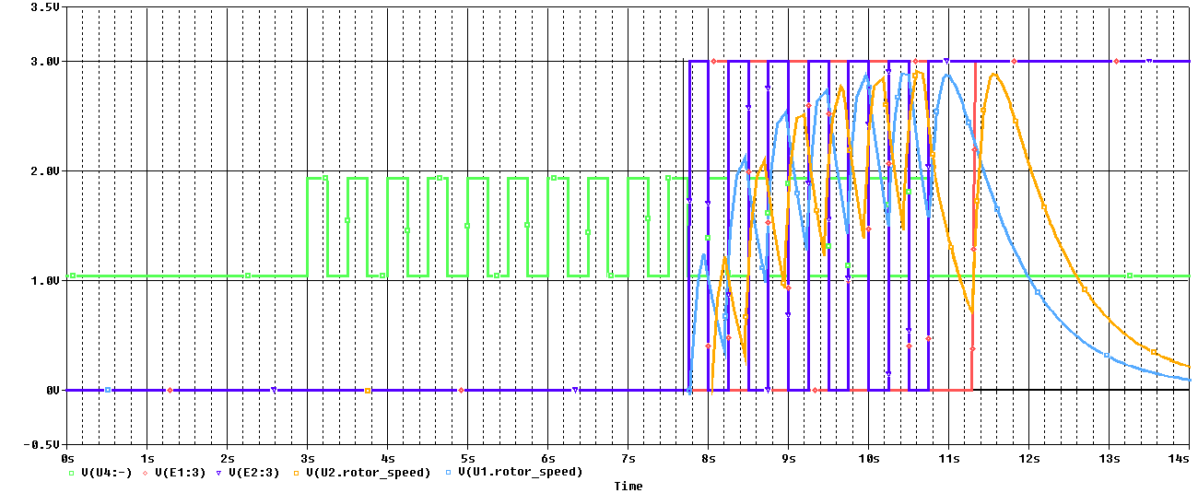 To perform the simulation, the user's input is replaced by a constant 3VDC signal. The sensor's output is a square wave current generator of period 0.5s oscillating between 0.90µA and 1.88µA. A transient analysis of 14s is executed: the amplified sensor output, the state of the motors and their speeds are displayed on (Graphs 1) below.

*Graphs 1: Graphical interpretation of the simulations.*

Overall, it appears the simulation reflects the theoretical expectations. During the first 8s both motors states are switched to 0V and the motors are turned off. Then both motors start changing state according to the amplified sensor's output displaying in each case a certain speed. Finally, when the sensor's amplified output remains constant, the left motor switches from 0V to 3V after 0.5s as expected and the motor's speed effectively reaches a certain peak before decreasing exponentially at the same rate as the capacitors charge.

Prototype

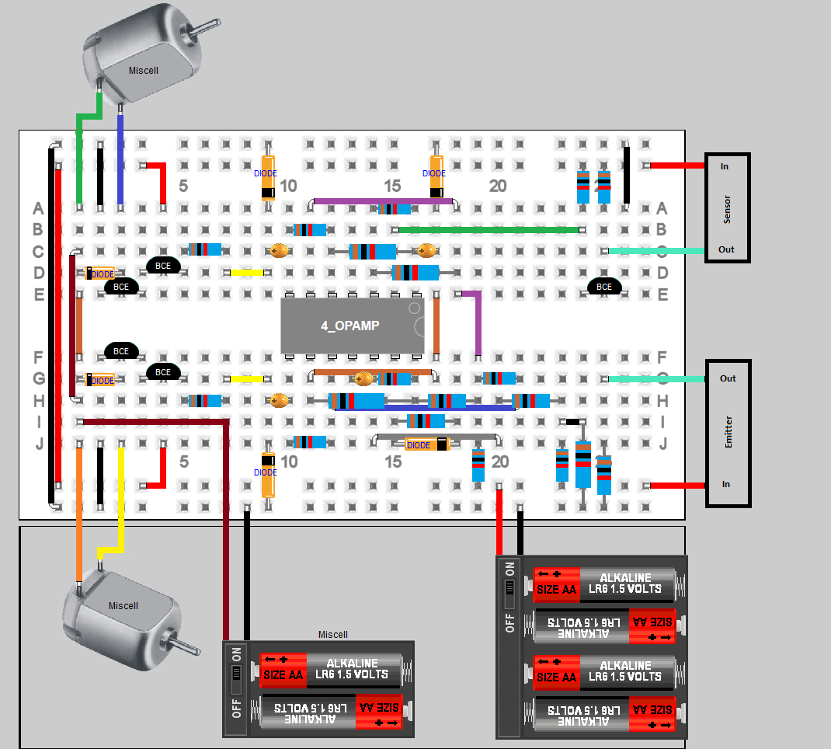 Following the simulation, a prototype is built based on the designed circuit. The components used and their disposition on the breadboard are shown in (figure 3) below.  
  
 *Figure 3: The components disposition on the breadboard.*  
  
  
The connections and the nodal behaviors are checked using a DMM with the motors disconnected. Once all of the mistakes in the circuit construction are corrected, the motors are connected and a test track is built using white papers and a black permanent marker. The thickness of the line is 0.8cm. Moreover, 10µF capacitors are used in the motors’ control system to start with. The device is placed at the beginning of the line and the user’s input set to 0V.

The user’s input is switched to 3V and a stop watch is used to record the time. Initially, the device waits around 7.4s before starting to follow the line. This is probably due to the fact the op-amp in the time enabling system draws current, reducing the capacitor charge time. To solve this problem the resistance RT1 is increased to 6.2MΩ. The device follows the line but once the end of the line is reached, the device performs a 180° turn before reaching the line again and following it in the opposite direction.

Checking the spiral enabling system behaviour, this time with the motors connected, its output VSPIRAL seems to never drop below 0.75V. This seems again due to the current drawing at the op-amp inputs. However, after disconnecting the motors, VSPIRAL can drop below 0.75V. Furthermore, the more current the op-amp needs to provide, the more input current is drawn apparently. The amount of current flowing in the RC circuit of the spiral system is thus increased without modifying the RC product. Consequently, the capacitance is fixed to 10μF and the resistance to 36kΩ.

With these modifications, the starting timing delay is effectively 8s and a spiral path is followed once the end of the line is reached.

Design Enhancements

From the described circuit, two possible enhancements which would lower the power consumption and simplify the user’s input mechanism can straightforwardly be implemented. The first consists in replacing the power bipolar transistors used in the motors’ control system by power MOSFETs while the second is about implementing a sound sensor which would switch on and off the user’s input.

# Power MOSFETs

Replacing bipolar transistors with FETs would be an enhancement for the power consumption and for the circuit reliability. In fact, the main factor determining power consumption is current. Lowering current would therefore lower power consumption. Since FETs are controlled by the voltage at their base, and BJTs by the current flowing in their base, FETs definitely consume less.

Only a single power MOSFET would be needed, replacing the present transistor connected to the motor. The exact same RC circuit would be kept but the resistor and capacitor would be connected in series between the motor state output and the ground, while the node shared by both components would be connected to the MOSFET’s gate. This new circuit design is shown below (figure 4).   
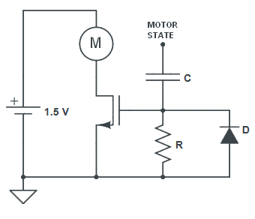  
 *Figure 4: Circuit design improvement with Power MOSFETs*  
  
 The resistor and capacitor values would depend on the MOSFET characteristics, but overall the resistance should be high and the capacitance low to reduce power consumption. Moreover, this would decrease the current provided by the motor control op-amps, which would increase the resistance and decrease the capacitance in the spiral RC circuit as well.

# Sound sensor

A sound sensor could be used to control the user’s input. This sensor would trigger it on or off in response to a certain frequency sound produced by the user. For instance, clapping would switch either on or off the user’s input and therefore enable or disable the circuit.

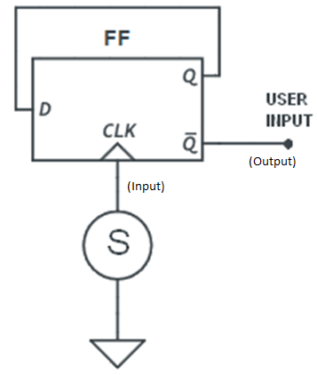 To achieve this, a simple sound sensor combined with a D-Flip Flop could be implemented. Basically, the negative terminal of the sensor would be grounded and the positive would be connected to the Flip-Flop clock input. The flip flop input would be connected to its inverted output, while its non-inverted output would be connected to the user’s input. The sound sensor system is shown   
below (figure 5).   
  
   
  
  
  
  
  
  
  
  
  
  
  
  
  
  
  
  
  
  
  
  
  
  
  
  
  
  
  
  
  
  
  
  
  
  
  
  
  
  
   
  
  
   
  
  
 *Figure 5: Sound sensor system circuit design*  
  
 Each time the user claps his hands, a clock pulse would be produced which would enable the circuit if it is currently disabled and reciprocally.

Cost and procurement

|  |  |  |  |  |
| --- | --- | --- | --- | --- |
| **Components** | **Manufacturer Part No** | **Price (£)** | **Quantity** | **Company** |
| High Speed Infrared Emitting Diode | TSFF5210-CS12 | 0.47 | 1 | VISHAY |
| Silicon PIN Photodiode | BPV10NF | 0.64 | 1 | VISHAY |
| Low voltage fast-switching NPN power transistors | 2STX1360 | 0.124 | 4 | STMICROELECTRONICS |
| Rail-to-Rail Op Amp | MCP6284-E/P | 1.35 | 1 | MICROCHIP |
| Resistors |  | 0.01 | 19 | LABORATORY |
| Capacitor Ceramic 1µF |  | 0.05 | 2 | LABORATORY |
| Capacitor Electrolytic 10µF |  | 0.20 | 2 | LABORATORY |
| Transistor BC548 | 2N5089G | 0.15 | 1 | LABORATORY |

The group managed to respect the deadlines set in the management plan of last term. As a result, a final and working product is obtained, meeting the design requirements. Indeed, the EEBug has a precise starting delay of 8s before it follows a 0.8cm thick black line over a white background. Once the end of the line is reached, a spiral is drawn whose shape can be easily modified by altering capacitances. Moreover, this design offers many enhancement possibilities including a low power consumption implementation with MOSFETs as well as an innovative sound enabling system.